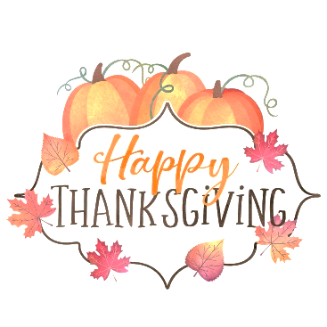
Two Chefs’ Thanksgiving Menu 2020

To insure availability, please place orders by 4:00 pm, Monday November 23rd
Pick up orders on Wednesday November 25th between 2:00 and 6:00 pm

Place the amount of each item that you desire on the provided lines.
Spice Rub (Season a 12-15 lb. bird) $3.99
___ A blend of herbs, spices, seasonings, and fresh sage compound butter to season your turkey

Rolls
___ Mini Yeast Rolls, slightly sweet, soft and ready to warm $4.25 doz.

Soup (qt. serves 3-4) $9.00 qt.
___ Brunswick Stew, autumn vegetables in spicy tomato broth with smoked pork
Dressing (Lb. serves 2-4) $5.99 lb.
___ Traditional Bread Stuffing with aromatic vegetables, light stock and fresh herbs
Potatoes (Lb. serves 2-4) $5.99 lb.
___ Yukon Gold Mashed Potatoes with Real Butter and Cream

___ Roasted Sweet Potato with Ancho-Maple Glaze
Cranberry (serves 2-4) $5.75 pint
___ Cranberry Citrus Relish, freshly ground with Oranges and Agave

Vegetables (Lb. serves 2-4) $7.25 lb.
___ Fresh Green Beans, Poached Leeks, Garlic Confit and Lemon Olive Oil

___ Roasted Brussels Sprouts with Smoked Bacon and Caramelized Hazelnut
Gravy (Quart serves 4-6) $9.75 qt.
___ Old fashioned turkey gravy with thyme and a hint of pepper

Desserts (serves 2-8) $16.75 ea.
___ Classic Pumpkin Pie with Sweet Cream

___ Apple Streusel Pie with Oatmeal, Brown Sugar, & Spices

Name________________________________ Phone_________________________________
Please Print

Two Chefs, Eastside 284.9970 Two Chefs Cafe & Market, Downtown 370.9336

