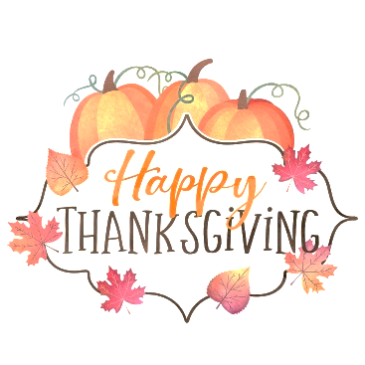
Two Chefs’ Thanksgiving Menu 2021

To insure availability, please place orders by 4:00 pm, Monday November 22nd
Pick up orders on Wednesday November 24th between 2:00 pm and 6:00 pm

Place the amount of each item that you desire on the provided lines.
Example
1
___ Two Chefs Thanksgiving Meal

Rolls
___ Mini Yeast Rolls, Slightly Sweet, Soft and Ready to Warm $4.25 doz.

Soup (qt. serves 3-4) $9.00 qt.
___ Brunswick Stew, Autumn Vegetables in Spicy Tomato Broth with Smoked Pork
Dressing (Lb. serves 2-4) $5.99 lb.
___ Traditional Bread Stuffing with Aromatic Vegetables, Light Stock and Fresh Herbs
Potatoes (Lb. serves 2-4) $5.99 lb.
___ Yukon Gold Mashed Potatoes with Real Butter and Cream

___ Sweet Potato Soufflé with Hot Honey and Hazelnut Butter
Cranberry (serves 2-4) $5.75 pint
___ Cranberry Citrus Relish, freshly Ground with Oranges and Agave

Vegetables (Lb. serves 2-4) $8.25 lb.
___ Fresh Green Beans, Leeks, Walnuts and Tarragon Butter Sauce

___ Brussels Sprouts, Creamy Onion Sauce and Chopped Herbs
Gravy (Quart serves 4-6) $9.75 qt.
___ Old Fashioned Turkey Gravy with Thyme and a Hint of Pepper

Desserts (serves 2-8) $16.75 ea.
___ Pumpkin Tart with Caramel Praline Pecan Topping

___ Apple Streusel Pie with Oatmeal, Brown Sugar, & Spices

Name________________________________ Phone_________________________________
Please Print (First, Last)

